COMMUNICATION NETWORK ROUTING USING FLOYD-WARSHALL ALGORITHM

INTRODUCTION:
To determine the shortest path between every pair of nodes in a communication network using the Floyd-Warshall algorithm. The Floyd-Warshall algorithm is a dynamic programming algorithm used to find the shortest paths between all pairs of vertices in a weighted graph. It is especially useful when indirect routes provide shorter paths than direct connections.

Problem Statement
A communication network consists of multiple nodes where not all nodes are directly connected. The system needs to compute the shortest path between every pair of nodes to optimize routing.

6. Algorithm
Step 1
Initialize the distance matrix with graph weights.
Step 2
Consider each vertex as an intermediate node.
Step 3
Update distances using:
Distance[i][j] = min(Distance[i][j], Distance[i][k] + Distance[k][j])
Step 4
Repeat until all vertices have been used as intermediate nodes.

7. Python Program
INF = float('inf')

def floyd_warshall(graph, n):
dist = [row[:] for row in graph]

for k in range(n):
for i in range(n):
for j in range(n):
if dist[i][k] != INF and dist[k][j] != INF:
dist[i][j] = min(dist[i][j], dist[i][k] + dist[k][j])

return dist

n = 3

graph = [
[0, 5, INF],
[2, 0, 3],
[INF, INF, 0]
]

result = floyd_warshall(graph, n)

print("Shortest Distance Matrix:")
for row in result:
for value in row:
if value == INF:
print("INF", end=" ")
else:
print(value, end=" ")
print()

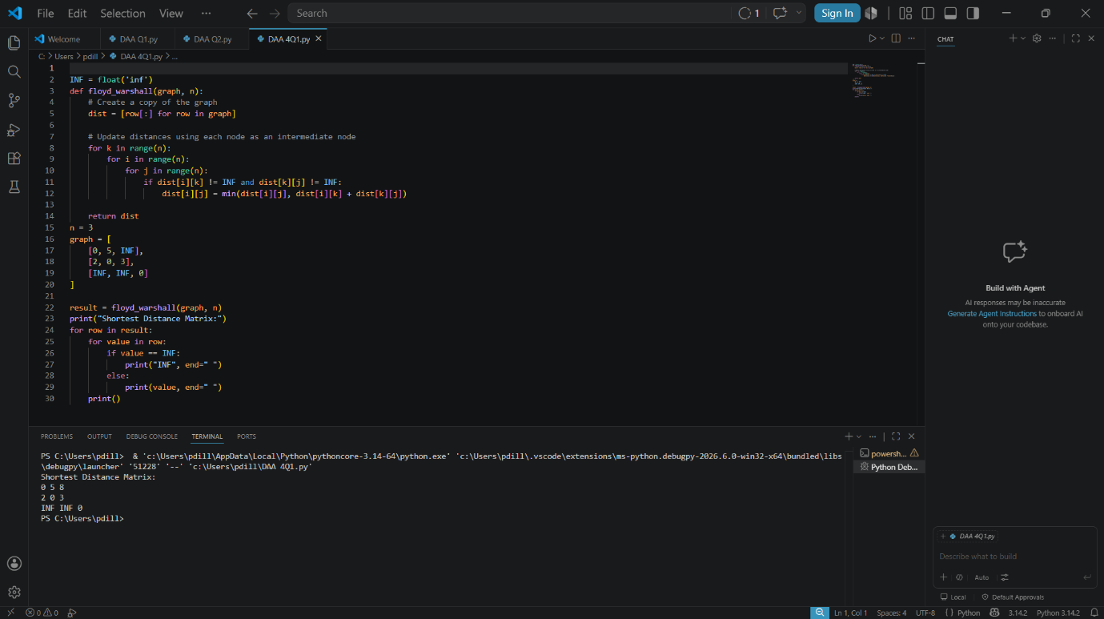

9. Time Complexity
Complexity Type | Value
Time Complexity | O(n³)
Space Complexity | O(n²)

10. Applications
- Communication Networks
- Routing Protocols
- Traffic Navigation Systems
- Railway Networks
- Computer Networks

11. Advantages
- Computes shortest paths between all node pairs.
- Supports indirect route optimization.
- Simple implementation.
- Effective for dense graphs.

12. Conclusion
The Floyd-Warshall algorithm efficiently computes shortest paths between every pair of nodes in a communication network. It improves routing performance and is widely used in network optimization problems.

13. References
- Thomas H. Cormen, Introduction to Algorithms.
- Data Structures and Algorithms Notes.
- Dynamic Programming Concepts.

